**EXPERIMENT -3: Searching and pulling images**

**Ques-1:** Do the following

1. Search an apache image
2. Pull appropriate apache image
3. Check whether the image is pulled or not
4. Run the apache and check port as it is not exposed outside
5. Rerun apache with -p option to expose the port outside
6. Check and browse in any browser
7. Run once again by customizing the port
8. Try to change the content of the index.html file

**Step-1:** First let’s see the available containers. There are no existing containers.

docker ps -a



**Step-2:** Search an apache image using the command:

docker search apache

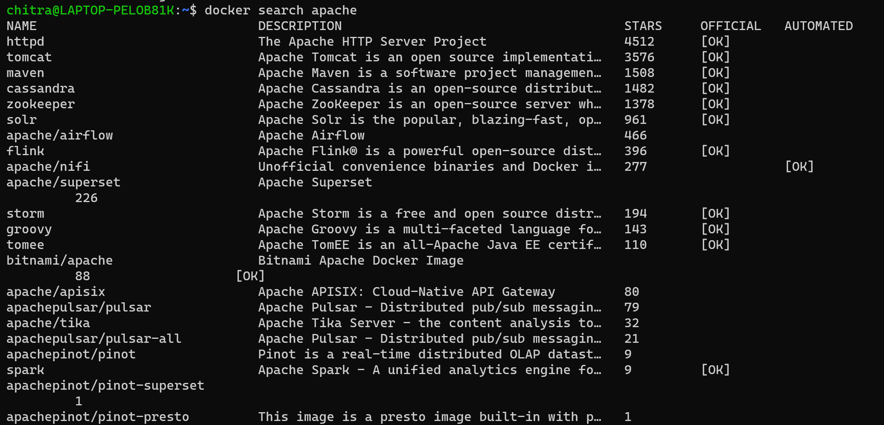

**Step-3:** Now pull the appropriate apache image. Here I am pulling the “httpd” image

docker pull httpd

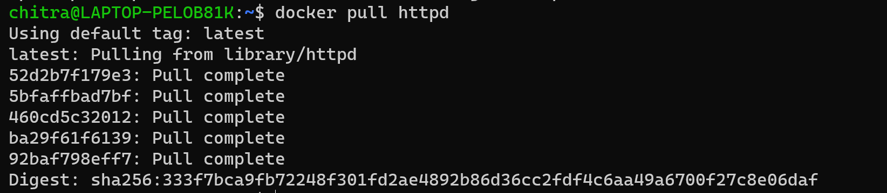

**Step-4:** Now check whether the image is pulled successfully or not

docker images

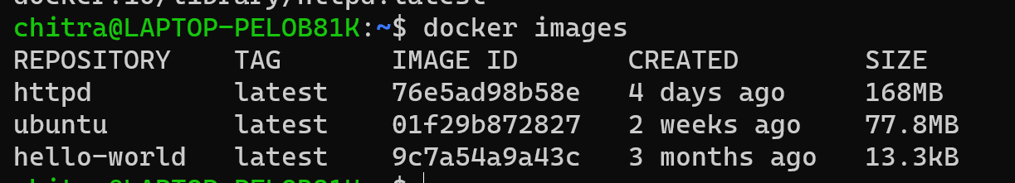

**Step-5:** Now run the server and check port. Here it is not showing anything because the port is not exposed outside. So will will stop this container and remove it.

docker port mywebserver

docker stop mywebserver

docker rm mywebserver

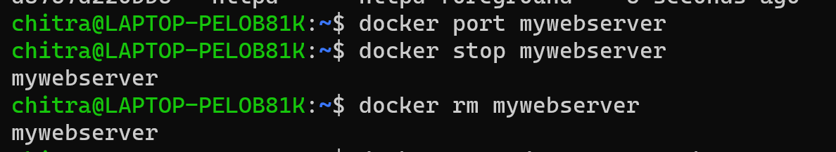

**Step-6:** Now, again create and run a httpd container but now with -p option by customizing the port.

docker run -d --name=mywebserver -p 8080:80 httpd



**Step-7:** Now check the port by running it in browser or using the curl command. Running this command , will attempt to make an HTTP request to the IP specified and request for the HTML.

curl 0.0.0.0:8080



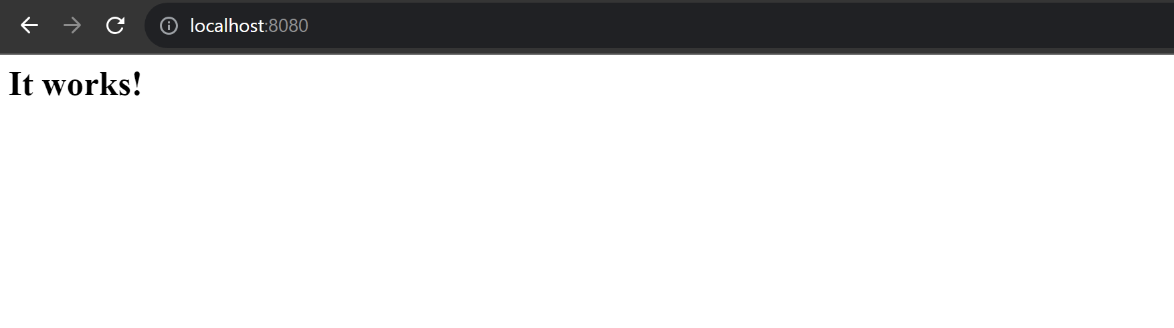

**Step-8:** Now here we can see that the port is exposed in the ports section in the details

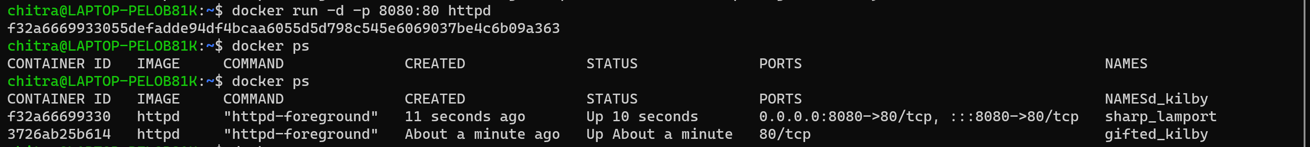

**Step-9:** In order to change the content of the html file, we need to open the interactive shell by using the command:

docker exec -it mywebserver bash

Now update, upgrade the server and install any editor inside it:

apt-get update

apt-get upgrade

apt-get install vim

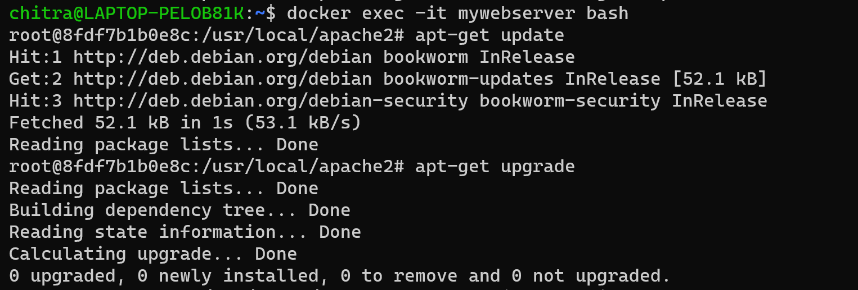

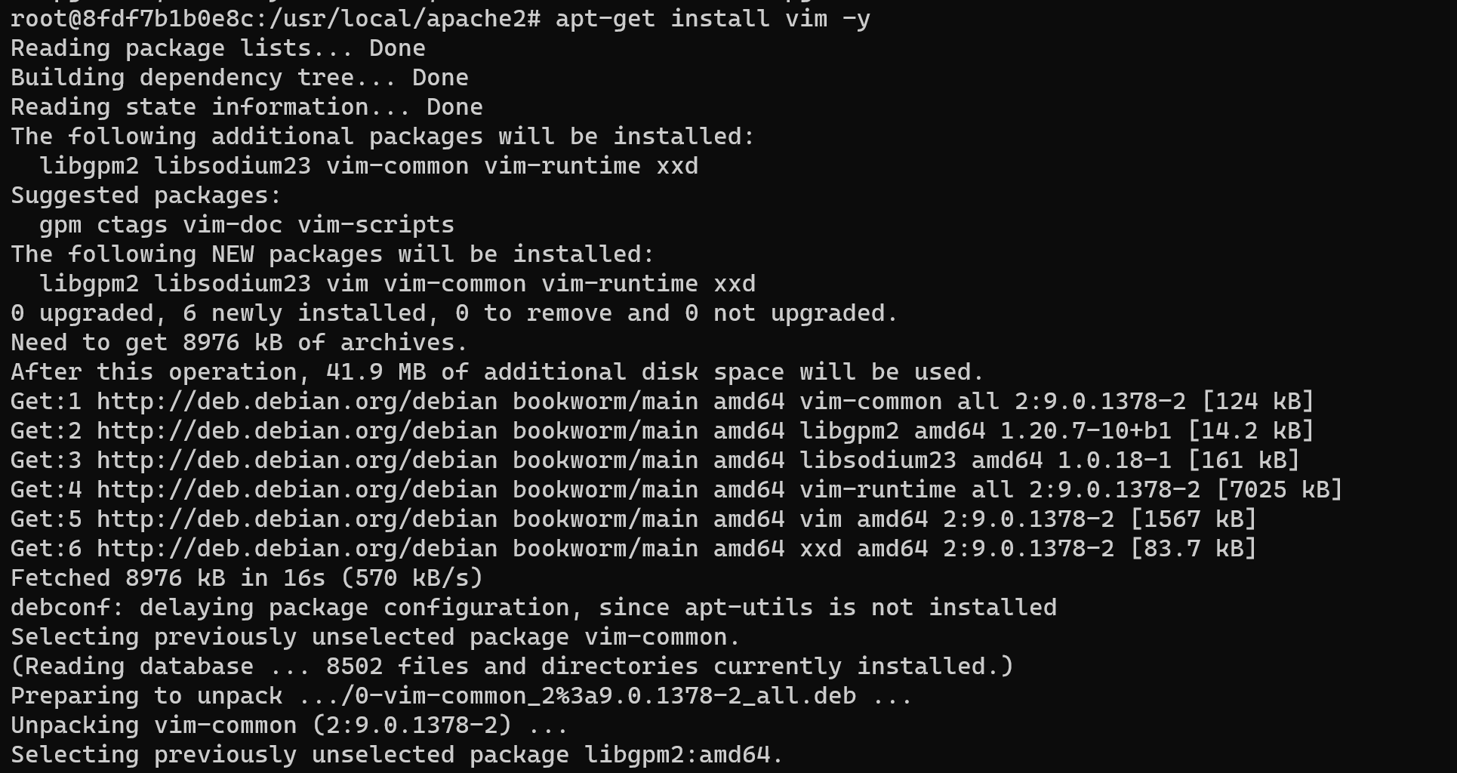

**Step-9:** The html file is present inside the “htdocs” folder. So navigate to the folder and then edit the file.

cd htdocs

vim index.html

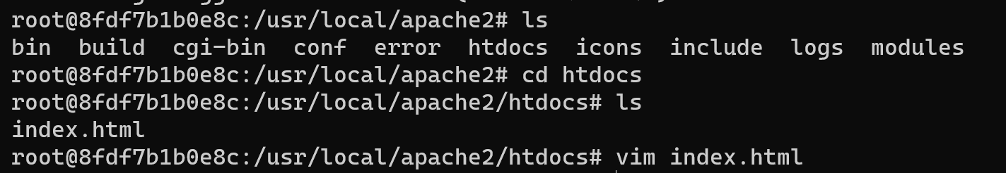

In order to insert text, press “I” and then edit the content. Save the file and exit using the “:wq”

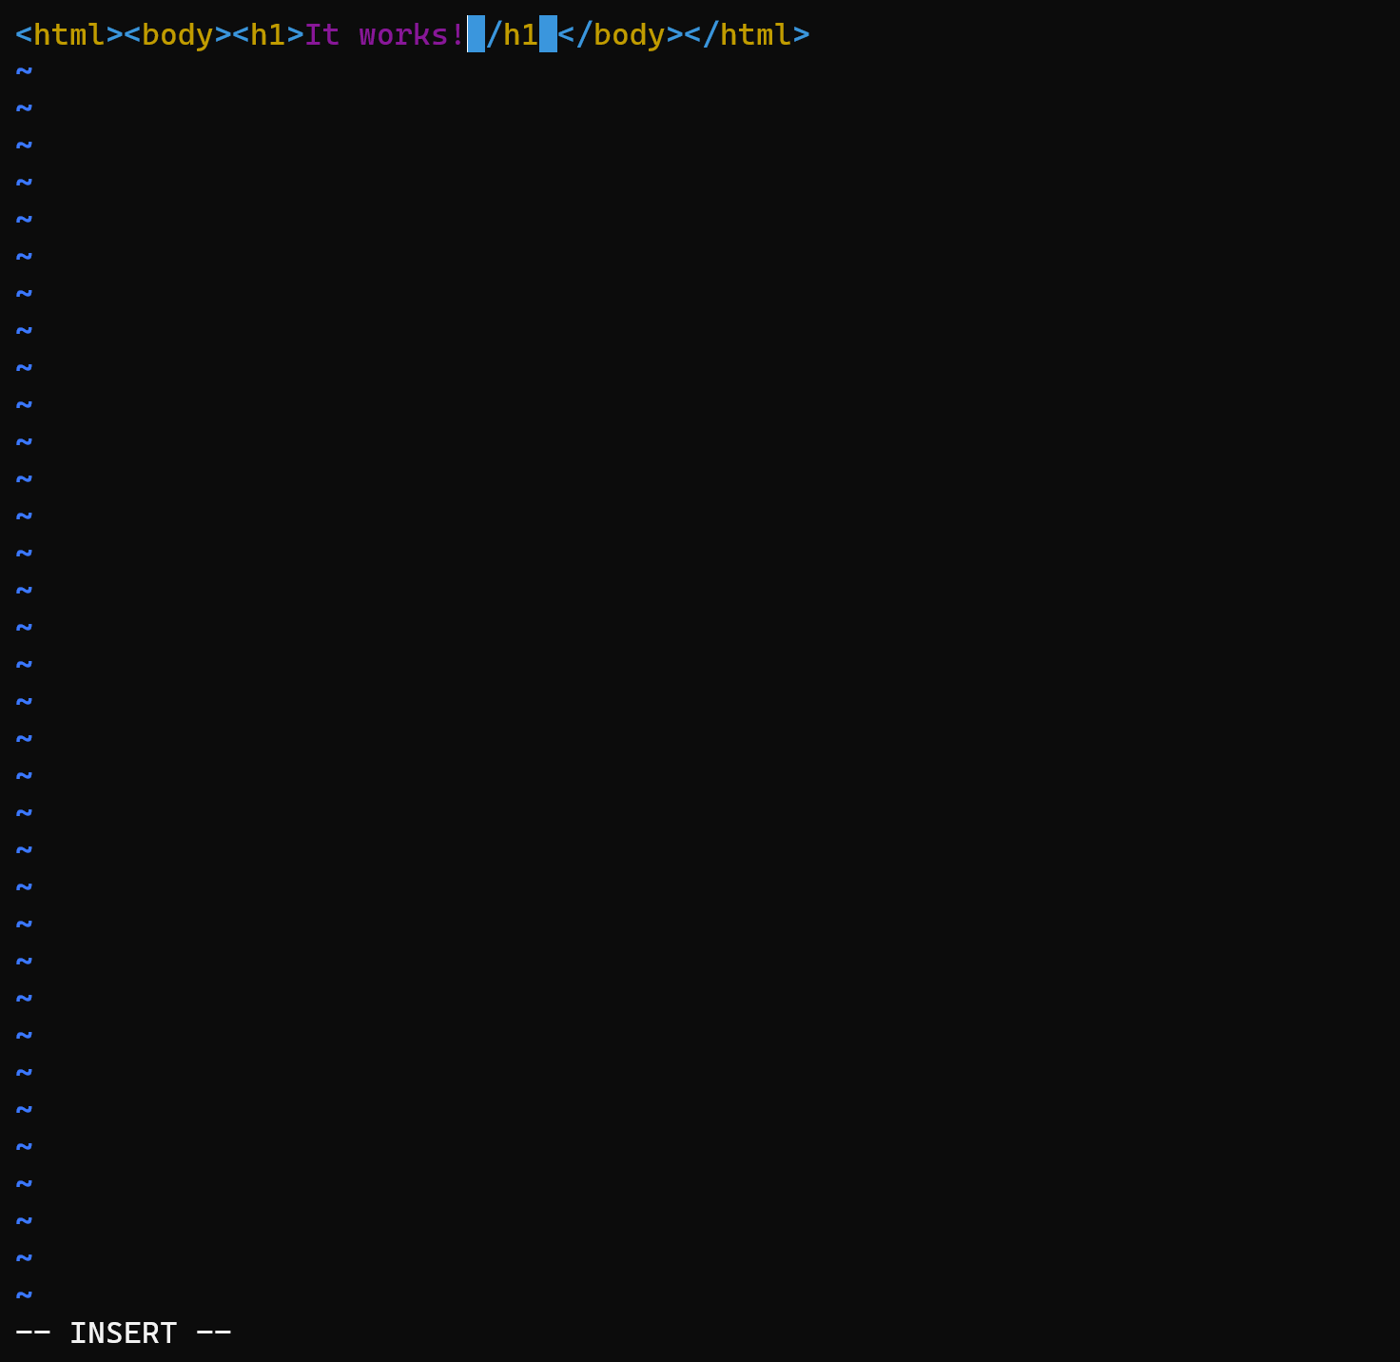

**Step-10:** Now open it in browser and check again whether the content is modified or not.

